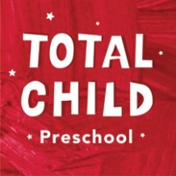
Total Child Tuition Rates 2020-2021
Full Day:
Full day programs are offered M – F, 8:00am – 5:00pm, 49 weeks per year. We are closed for 2 weeks in late December/early January, and 1 week in August. Please refer to our calendar for other days the program is closed.
There is a $50 registration fee. A two-week deposit is required at time of enrollment, which will be applied to the last two weeks of tuition as long as a month notice is given.
2-year-old (Room 23): $380/week
3-year-olds (Room 22) and 4-year-olds (Room 26): $369/week

Part Day:
Part Day students who are 2 by September 1 or 3 by September 30 will attend August 10 – June 4, M – F, from 9:15-11:45.
2-year-olds (Room 23) and 3-year-olds (Room 22): $170/week

Part Day students who are 4 by December 31 will attend in Room 25, from August 10 – June 4, M – F, from 9:15-12:00.
4-year-olds (Room 25): $182.50/week

*There is a 5% discount for siblings

